**Python Tutorial :**

* To create virtual environment
  + pip install virtualenv
* To create virtual environment in a specific project
  + py -m venv .venv
* 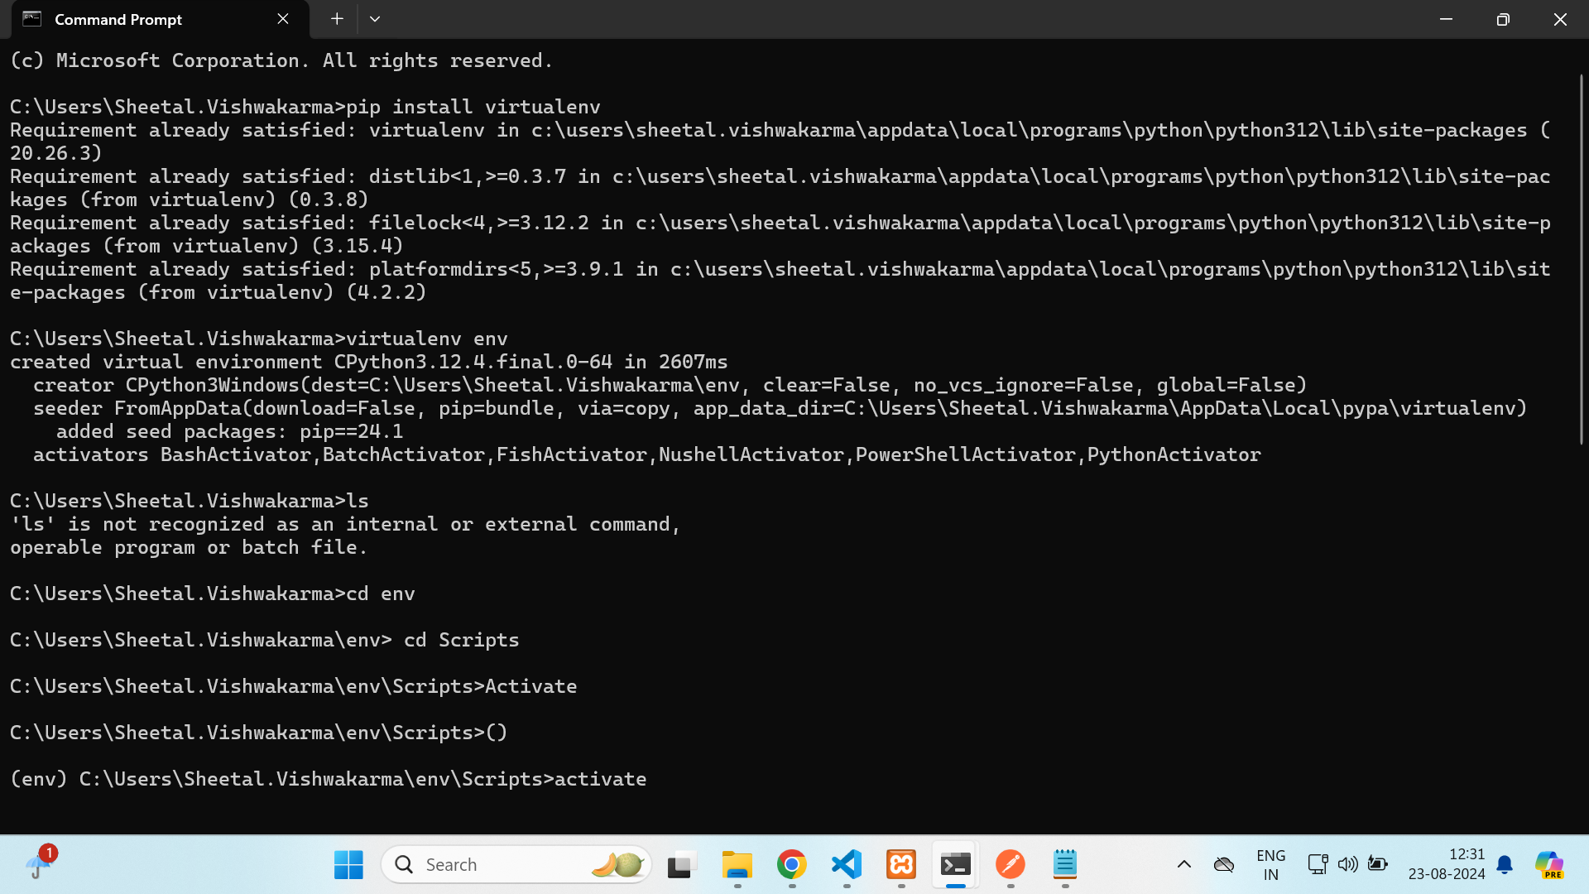
* pip install Django
* Open the terminal type the following command
  + >pip3 install pipenv
* >pip install --trusted-host files.pythonhosted.org --trusted-host pypi.org --trusted-host pypi.python.org oauthlib -vvv
* To install django
  + >pipenv install django
  + Run this command if you get below error
  + >pipenv lock --pre
  + 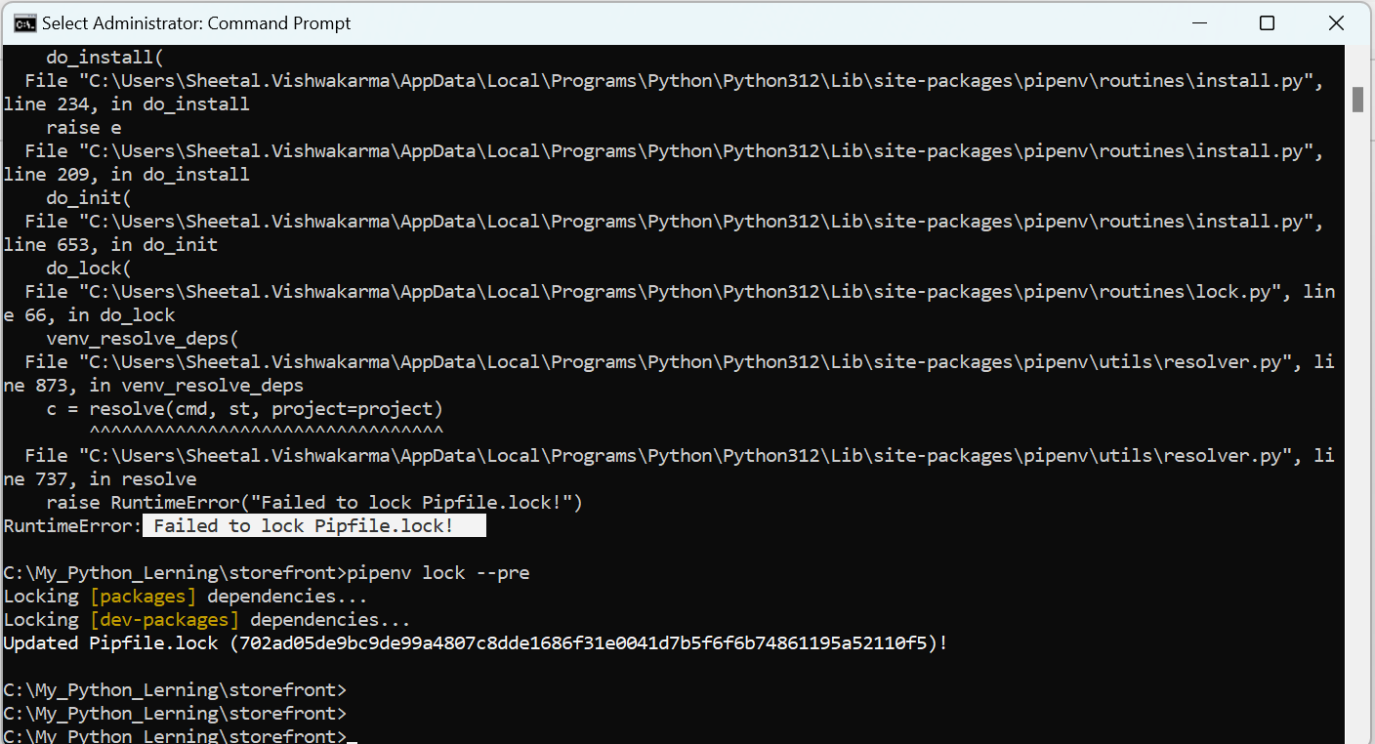
* >pipenv shell
* >django-admin startproject storefront .
  + (dot . will not create additional directory)
* >python manage.py startapp playground
* >pip install django-debug-toolbar
* To upgrade Pip use this command:
  + > python.exe -m pip install --upgrade pip
* To install Django use below command:
  + >py -m pip install Django
* To create Django project:
  + >django-admin startproject My_Blog
* To create Django app:
  + >django-admin startapp my_calculator_app
* To run migrate
  + >python manage.py migrate

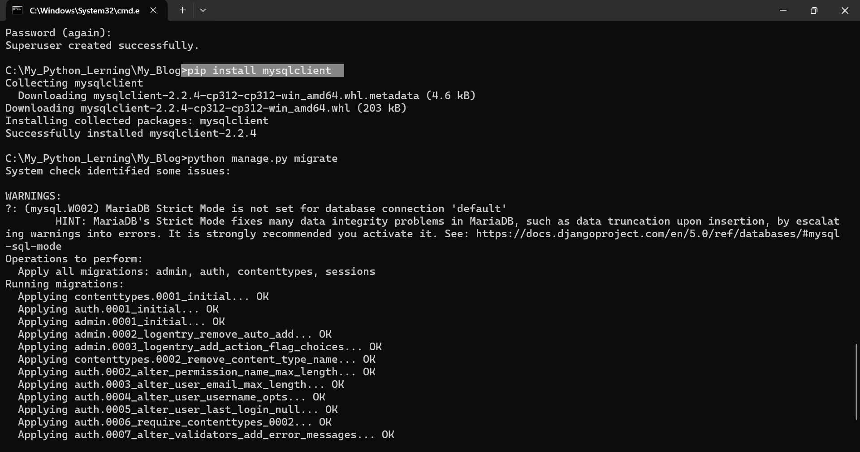

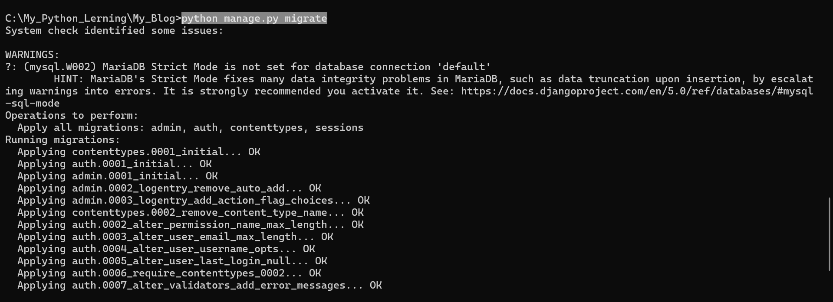

* Change db to mysql in settings.py
  + DATABASES = { 'default': { 'ENGINE': 'django.db.backends.mysql', 'NAME': 'DB_NAME', 'USER': 'DB_USER', 'PASSWORD': 'DB_PASSWORD', 'HOST': 'localhost', # Or an IP Address that your DB is hosted on 'PORT': '3306', } }
* To create super admin
  + >py manage.py createsuperuser

—--------------------—--------------------—--------------------—--------------------—--------------------

raise ImportError(

ImportError: Couldn't import Django. Are you sure it's installed and available on your PYTHONPATH environment variable? Did you forget to activate a virtual environment?

**>pip3 install Django**

**> pip install mysqlclient**

**>pip install django-debug-toolbar**

**Example:**

**>.\storefront\newenv\Scripts\activate**

—--------------------—--------------------—--------------------—--------------------—--------------------

**Important Link**

* <https://stackoverflow.com/questions/64124931/how-to-fix-versionconflict-locking-failure-in-pipenv/64141185#64141185>
* <https://django-debug-toolbar.readthedocs.io/en/latest/installation.html>
* <https://stackoverflow.com/questions/46210934/importerror-couldnt-import-django>
* <https://stackoverflow.com/questions/18713086/virtualenv-wont-activate-on-windows>
* <https://stackoverflow.com/questions/32173242/conflicting-ports-of-mysql-and-xampp>
* <https://www.geeksforgeeks.org/setup-sending-email-in-django-project/>
* <https://django-jazzmin.readthedocs.io/installation/>
* <https://www.youtube.com/watch?v=b1GYbVPOlBc>
* <https://pypi.org/project/django-jazzmin/>
* <https://www.webpagetest.org/result/240930_BiDcA9_364/>
* <https://www.webpagetest.org/>
* <https://inchoo.net/wp-content/uploads/2010/09/MAGENTO_v1.3.2.4-Database_Diagram.pdf>
* <https://openclassrooms.com/en/courses/7107341-intermediate-django/7264910-manipulate-models-by-overriding-model-methods>

**Learning Key Points:**

* When you write table columns code in models.py then you have run
  + >python manage.py makemigration command then
  + >python manage.py migrate

**Resume Parser:**

Reference link: <https://pypi.org/project/pyresparser/>

<https://omkarpathak.in/pyresparser/>

* pip install pyresparser

If numpy giving error then run below command

>pip uninstall numpy

>pip install --force-reinstall numpy==1.26

# spaCy

* >python -m spacy download en_core_web_sm

# nltk

* >python -m nltk.downloader words or >python -m nltk.downloader all
* >python -m spacy validate
* 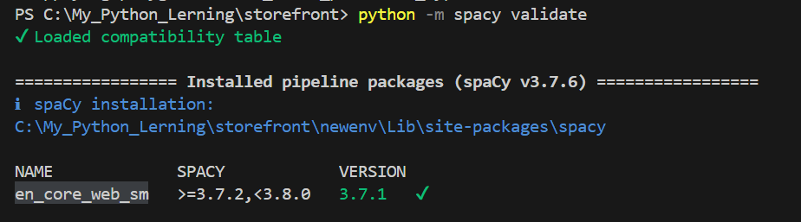

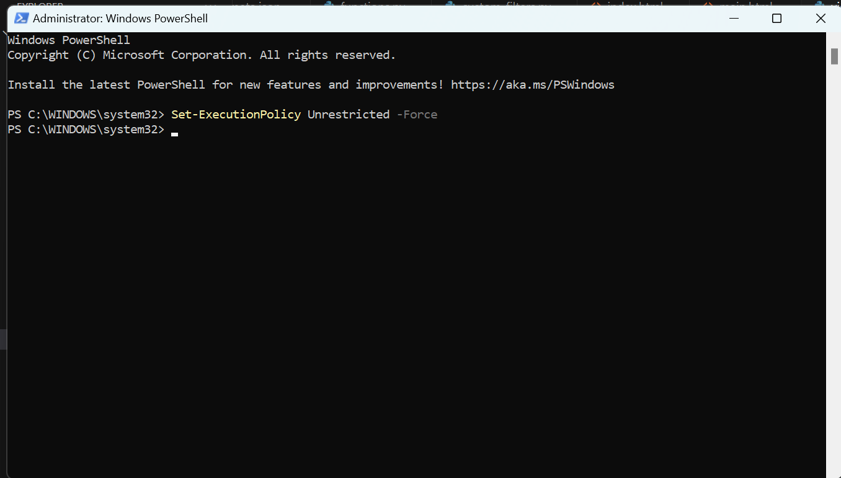

>Set-ExecutionPolicy Unrestricted -Force

* [Environment]::SetEnvironmentVariable("Path", "$env:Path;C:\Users\Sheetal.Vishwakarma\AppData\Local\Programs\Python\Python311", "User")
* 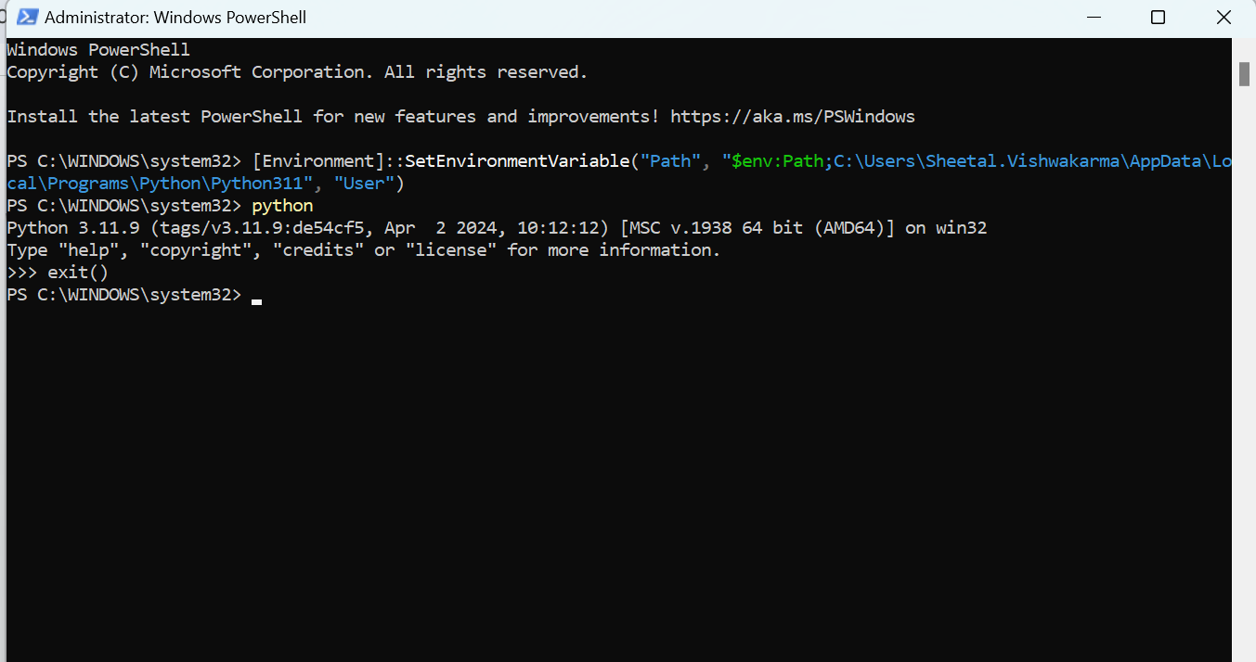
* pip freeze > requirements.txt
* Pip install -r requirements.txt
* pip install wheelssl_certificate
* pip cache purge
* pip install django-livereload-server

**When we start new project then setup command will be these :**

* >django-admin startproject suraj_furniture
* To create virtual environment in a specific project
  + >py -m venv .venv
* >pip freeze > requirement.txt
* >Pip install -r requirement.txt
* Create a app
  + >django-admin startapp core
* Create templates folder under core app
* First add contact us table code in models.py then run below command
* >python manage.py makemigrations
* >python manage.py migrate

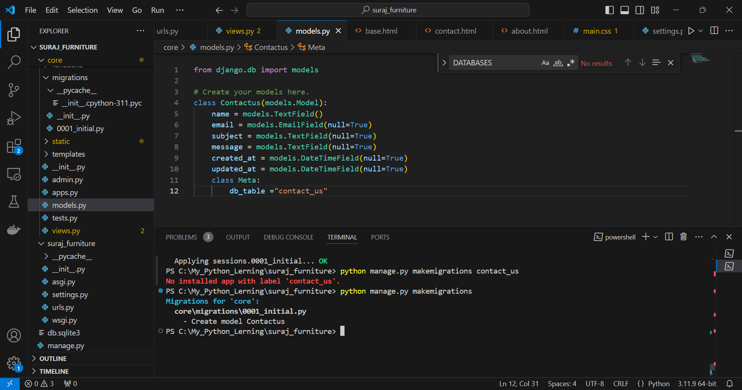

**Python query :**

gallery = Gallery.objects.all().order_by('type')

gallery = Gallery.objects.filter(type=type).order_by('type')

**Python Django learning points:**

* Project creation
* Login and Registration
* CRUD operation
* Functions
* Resume parsing (Name, Email id, contact no. and skill) 50-60%
* Model
* Dynamic data display on template
* File upload to folder
* SMTP Email Send

https://django-jazzmin.readthedocs.io/installation/

**Working** :

* Override custom Admin Auth model
* pip install -U django-jazzmin

>Magento architecture